**Brian R Hill**

A Yorkshireman, Brian R Hill was born in the UK in 1951 and educated at Aireborough Grammar School in Yeadon near Leeds. He has a grown-up family and three grandchildren. Brian lives close to the beautiful Yorkshire Dales National Park. A keen amateur photographer, musician and composer, Brian derives much of his inspiration from the beautiful countryside of the region. A stroll through The Dales can provide Brian with a chapter full of ideas, although the areas he includes are often heavily disguised by the time the final draft is complete – Yorkshire, for example, is not famous for its volcanoes.



Before retiring, Brian worked in the Clothing, Retail and Lighting industries. He now divides as much of his time between writing, walking, photography and music as he can. Brian’s first novel, **The Shintae**, was first published in 2007, a 2nd edition was rereleased in 2017. A second fantasy novel, **Shadows from a Time Long Past** was published in 2011. A third fantasy, **The Mastig**, was published in August 2017. In 2016, Brian published a post-Brexit contemporary thriller, **Love, Lies and Treachery**, set in his home county of Yorkshire, England.

W: www.brianrhill.com

E: contact@brianrhill.co.uk **Novels**

Genre – Thriller

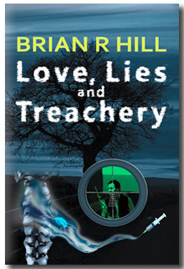

**Love, Lies and Treachery**

ISBN: 1537719319 ISBN-13: 978-1537719313 ASIN: B01MTWQGWO

Young, naive and idealistic, all Nathan wants is to change the world for the better. Involved in the affairs of the Party for National Unity, from its inception, Nathan's progress is rapid. After the party seizes control of the country, his own ruthless actions bring him to a prominent position. Then, over a matter of days, his life falls apart. Arrested, brutally interrogated, his loyalty questioned, he is released into a world without family or friends. He is an outcast. Now, he knows the true nature of the monstrous regime he helped create.

Uprooted, Nathan is resettled in a city many miles from his hometown. Alone and under surveillance, he has time to reflect on his past deeds and on the increasing brutality of the ruling party. Before he can hope to atone for his past deeds, he must regain the trust of his masters. To his horror, he learns of a new and deadly threat to the population by the government. Soon, he discovers all he needs to know about love, lies and treachery. Dictatorship, abduction and insurrection are a heady combination for anyone to handle.

WITH YORKSHIRE AND THE DALES AS ITS BACKDROP, FROM THE START, THIS THRILLER GRIPS THE READER'S ATTENTION

**Reviews for Love, Lies and Treachery**

This story is especially relevant in today's world, where governments want to capture more power and control over their populations. The characters are strong, the action is exciting. The author has created a frightening situation that makes the reader stand up and take notice.

Patricia Perry - Author

"...a novel that twists and turns and is extremely poignant in the present political climate..."

Ronnie Brown

Genre – Fantasy

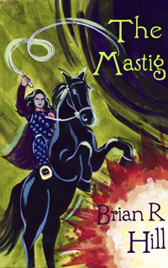

**The Mastig**

ISBN: 1543139035 ISBN-13: 978-1543139037 ASIN: B074SBTFKM

After days spent working in his father’s fields, a young man, Amron, celebrates the end of harvest drinking with his friends. Intoxicated, he wanders away, into the darkness. Next morning, he wakes to find his world changed forever. People he thought his friends have burned the village and murdered its occupants. His mother is dead, his father tortured and left gravely wounded. Only now does the wayward son learn of his true position. Standing in the way of his destiny are the vast armies of the despot Betlic. This usurper, who overthrew the last King of Xicalima, has in his possession the two most powerful objects in the known world, the Talisman of Grebarta and the Mantle of Agetha. Confident in his powers, Betlic believes nothing can prevent him from ruling the world.

On expanding his empire, Beltic discovers that the ancient magic, which created his talismans of power, forged two other objects. If brought together, these magical items have the potential to crush his hopes. Hunted by both Betlic and Amron, each with his own agenda, can Marazin and Karilyn, the heirs to these objects, survive long enough to bring together their talents to combine the Scraufin and The Mastig? In doing so, will they be in time to thwart both the evil of Betlic and the desires of the inexperienced rebel leader, Amron?

**Review for The Mastig**

Brian R. Hill’s **The Mastig** is a journey well worth taking. The characters are well rounded; the scenery is breath-taking and the reader is quickly absorbed into the story - Patricia Perry- Author

Genre – Fantasy

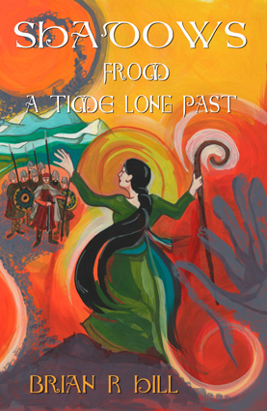

**Shadows from A Time Long Past**

ISBN: 1453737049 ISBN-13: 9781453737040 ASIN: B004RZICCM

The stranger, to whose aid Nerian comes, is young, beautiful and mysterious. Why is she so insistent he accept the gift of a Crook? It is a decision he soon regrets for he finds himself the target of a manhunt by the forces of the merciless Lord Sigeberht. But, instead of saving himself, why is Nerian risking his live to return the object?

Held captive within the tyrant’s castle, Naomi, the Crook’s Guardian, awaits her opportunity to escape. As Lord Sigeberht fails in his attempts to obtain the object, external forces take control of his mind, driving him blindly towards disaster.

While Nerian desperately seeks Naomi, unknown to him the Keeper of the Gauntlet also is making his way towards her. What links the Gauntlet and the Crook and why are the games played by Naomi in her childhood important? Released from confinement, Shadows of evil begin to spread across the land. What is the significance of Gabrielle, the Keeper’s kidnapped daughter? As a weapon against the forces of evil, the innocence of a child should never be underestimated.

**Review for Shadows from a Time Long Past**

Brian Russell Hill’s **Shadows from a Time Long Past** is an action-packed story that will keep the reader absorbed from the first page to the last. It is filled with memorable characters such as the devoted Almund, Keeper of the Gauntlet, who searches for Gabrielle, his kidnapped daughter; and young Nerian who is drawn into the conflict because of a chance encounter with Naomi, the Guardian of the Crook. The merciless Lord Sigeberht seeks not only the Crook but the Gauntlet because combining the two will grant him unimaginable power. Will he succeed?

Mr. Hill’s rich settings, remarkable characters and well-crafted story make this a must read.

Patricia Perry- author

Genre – Fantasy

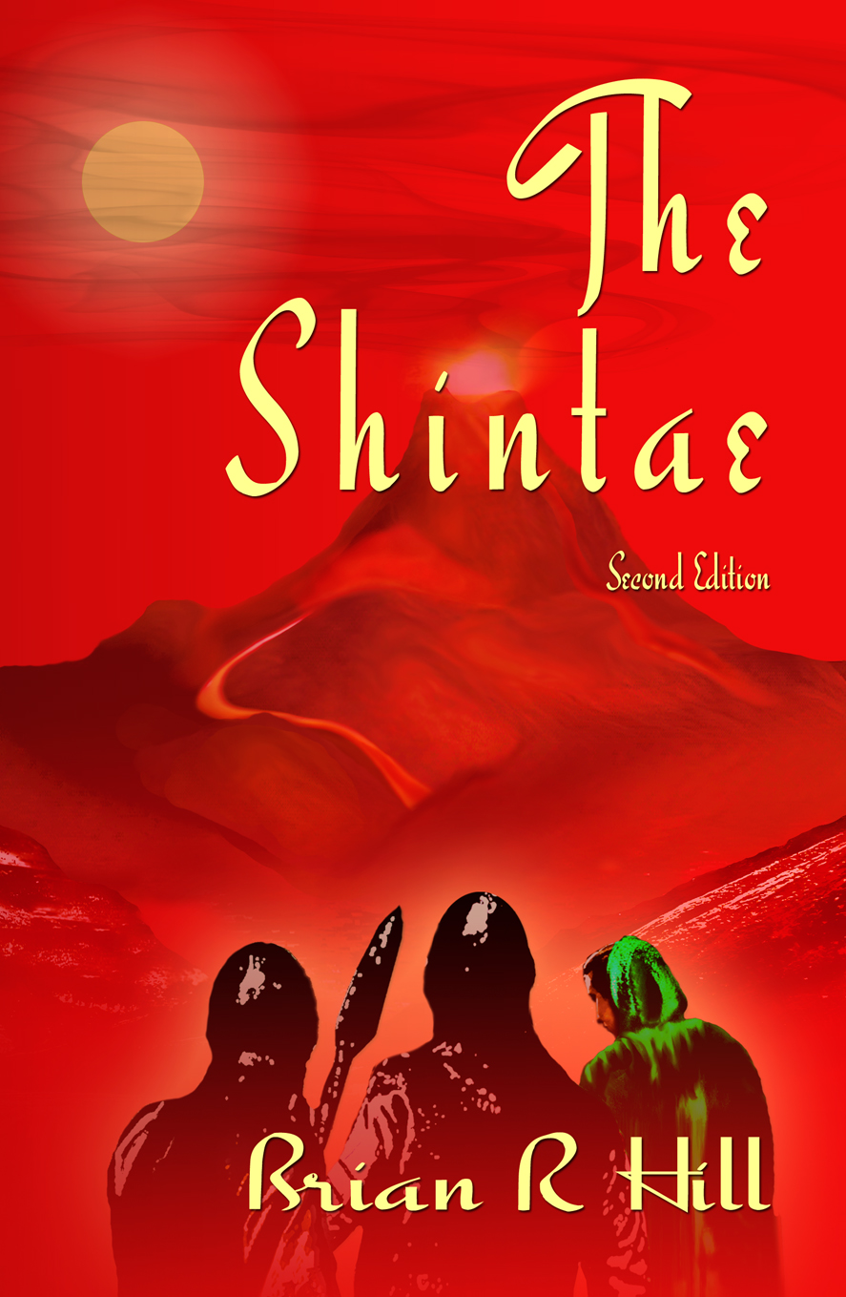

The Shintae

Second Edition

ISBN: 1541323025 ISBN-13: 978-1541323025 ASIN: B01MRBOM3Y

…two heroes and a heroine, two opposing nations, an enemy steeped in evil, adventure, all-out war and The Shintae, the Stone of almost unimaginable power. Only one nation can survive…

After recovering The Shintae, an ancient relic of mystical properties, the Maraen warrior Kaer is surprised by the enemy and left for dead. Surviving his injuries Kaer is once more charged with retrieving The Shintae and, with his companion Angharad, travels deep into the Cantaen Mountains in search of the object. Together and separately, Kaer and Angharad face great danger, adventure, natural disaster and all-out war before their arduous task can be completed.

Standing in Kaer and Angharad's way is Sartae, an antagonist whose evil ambitions know no bounds. A leader, whose cruelty and hatred is known and feared throughout the lands. As the mission progresses, Kaer and Angharad receive help from the most unlikely of sources but in the end, they must use all their skill and knowledge to keep themselves alive. As the venture races to its explosive climax, even this may not prove sufficient.

**Review for The Shintae**

The Shintae, a mysterious stone with magical powers, is entrusted to the forest-dwelling Maraens. The Cantaens, the Maraens’ enemies living in the mountains, steal the stone to use against them. The Maraen hero, Kaer, manages to get the stone back but is ambushed by a group of Cantaens and loses the Shintae to them. The race is on to retrieve the Shintae before the Cantaens learn to decipher the words that will set free its incredible power. Brian R. Hill’s fantasy tale is richly told. His characters are strong, determined and dedicated to their tasks. They face many obstacles yet refuse to yield to any of them. Mr. Hill’s story takes the reader on an incredible journey through snowy mountains, the aftermath of an avalanche and into a long-deserted city whose ghosts still watch out for the rare traveler that passes through. The most impressive description is that of Myssous, the Maraen capital. The Shintae is an exciting book that will draw the reader in from the moment they turn the first page. If you enjoy action, adventure and strong characters then read The Shintae. I highly recommend this book and am looking forward to Mr. Hill’s next book.

Reviewed by Patricia Perry, author, Quest for the Source of Darkness (7/06)